Lake of The Woods Homeowners Association
Newsletter – Summer 2020

Lake of the Woods Homeowners, this is a brief update on a few issues.

Board Positions:
The following positions were taken by the officers elected at our last annual meeting: Sharon Shapiro will continue to serve as HOA President, Dale Freygang will continue to serve as HOA Vice President, Kathy Negrelli continues as Treasurer, Carrie Brown is our HOA Secretary, and Jim Krumpelman serves as Alternate. The current Board members are serving for terms of varying duration in order to ensure continuity on issues and procedural matters. Therefore, at each HOA annual meeting, only a portion of the board will be newly elected. This way, the board will always be composed of some new members and some experienced members. Per our bylaws, the goal is for all future Board members to serve three-year term(s).

In addition to the board, Tom Lentz continues to oversee HOA financial matters, record keeping, and tax issues. Carrie Brown and Kristin Stetz pitch in on technologic issues, and various other persons are called upon as needed for help in their area of expertise. Each person cannot be specifically named in this newsletter, but thanks from the community are due to each.

The Front Entryway:
No doubt, everyone has seen the new landscaping at our front entryway with its new shrubbery, complementary large boulders, and improved lighting. Our Lake of the Woods sign and insignia are more brightly lit than previously, overhanging tree branches have been removed, and the large boulders are beautifully illuminated at night. Following are ‘previous’ and current pictures:

Previous landscape

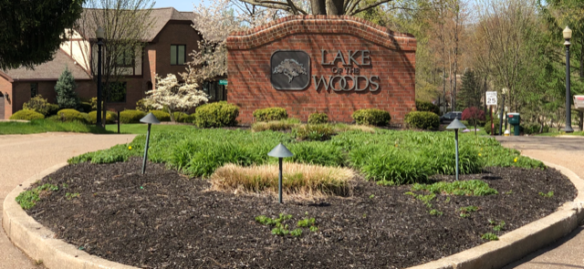

Now – daytime & night illumination

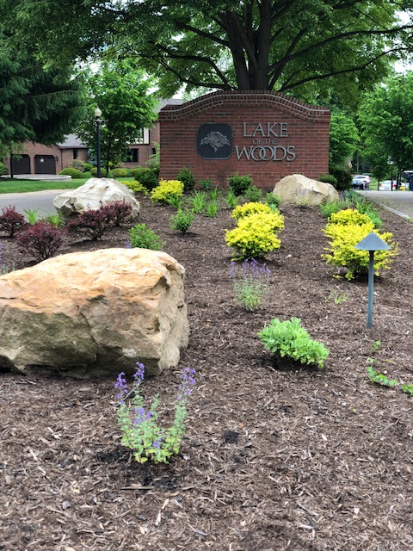
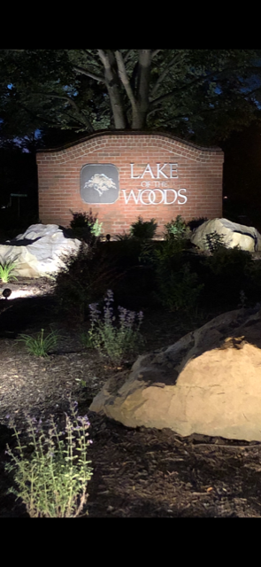

The landscaping and boulder design and installation was done by C.S. Triola Landscaping at a cost of $3800 (labor, materials and equipment), and the lighting was improved by Bluegrass Design, the same contractor we have been using, at a cost of $ 1375 for labor and materials. This landscape design was chosen both for hardiness and also with an eye toward 4 season interest, especially during our very long, gray winters. The boulders, boxwoods, and barberries should help out with a nice entryway presentation even during the winter. The LED lighting was chosen with an eye toward improving visibility from Smith Road in order to improve safety for drivers, and also to make Lake of the Woods easier to locate, as shown in the night time picture above.

The new shrubbery is being watered and monitored by Triola who also maintains the remainder of the entryway. A special thanks to Susan Powell who is allowing us to use her water to settle the new plants. Restoration of the HOA’s own water supply at the entryway was explored, however the cost was prohibitive. The first hurdle was to have the city turn on the water. Our account is labeled as an” irrigation account” and, as such, requires a backflow device to be in place prior to turn on. The city and the board, working together, could not locate an existing backflow device, nor could we find or remember any irrigation system. Backflow installation costs and maintenance would be the responsibility of LOW, not the city. After much exploration and discussion, the city tentatively agreed to allow turn on without a backflow device. We then learned that our entryway hose outlet is embedded in the cement sidewalk, and the water supply mechanism is located underground. The water has not been used for many years, so the consulting plumber felt that the mechanism had probably corroded and would require replacement. This would involve removing a section of the cement sidewalk, and digging 2 to 6 feet down to check and replace the supply mechanism. The mechanism’s cost without labor was “at least $500”. The labor charge would be prohibitive. Therefore, efforts to restore the LOW’s own entryway water supply were abandoned.

This is the current HOA board’s first full season maintaining the entryway, so it is a busy time. As you know, our landscape easement has always extended east and west along Smith Road; it is not solely the land abutting the turn into Lake of the Woods Blvd. The east easement required particular attention; crab grass had overtaken and replaced the lawn grass, weeds were thick, and the shrubs were doing poorly. A large portion of the east easement was re-seeded, extensive weeding, shrub fertilization and shaping, and bed delineation was required to make this area’s appearance consistent with the remainder of landscape. This is a one time additional cost to the routine landscaping fees.

The LOW HOA Bylaws:
One of the two major recommendations of Kaman & Cusimano, our HOA attorneys, was to have our Bylaws, also known as Code of Regulations, filed as required by the Ohio Planned Community Act of September 2010. Having filed Bylaws strengthens the HOA, improves our ability for any needed enforcement actions including collection of dues, and brings us up to date with Ohio legal requirements of HOAs.
Although the 1984 document with original signatures has been lost and could not be found, we were able to record and file the Code of Regulations that we have been abiding by. The board was able to accomplish this without incurring legal fees.

Gig Update:
Because of covid restrictions with the increased numbers of children schooling from home and adults working from home, there has been renewed interest in GIG. Thank you, John King, for following up with GIG.

Neither Fairlawn nor Akron is able to subsidize the extension of Fairlawn GIG outside of Fairlawn. At this time, the costs of a build out would have to be borne by the area wanting the build out. This may merit discussion with our councilman, Mr. Malik, since Lake of the Woods is second on the GIG expansion list, pending available funding.

A GIG build out would include all homes in an area such as LOW whether or not they are participating in GIG. Per a phone conversation with GIG on 7-24-2020, the build out cost into LOW is $165,000. The installation cost would be borne by those homes choosing to have GIG monthly service, and it would extend over a 2 year commitment. There is a possibility of the term being longer, which would reduce the monthly installation cost.
In addition to the monthly installation cost, there is a monthly fee for GIG service. The GIG monthly service fee is $82.50 for Gigabit internet, or $60.50 for 300mbps speeds upstream and downstream.

Example #1: If all 83 of the homes in LOW chose to have GIG service, then the installation fee of $165,000 would be divided among 83 homes. Each home would be paying $83 monthly installation cost, plus $82.50 GIG monthly service charge = $165.50 per month for the first 24 months only, and afterwards, it would be $82.50 monthly for Gigabit internet. (If a home chose to have the 300mbps, it would be $143.50 monthly for 24 months, then $60.50 for monthly service.)

Example #2: If only 50 of our homes chose to have GIG service, then the installation fee of $165,000 would be divided among 50 homes. This would be $137.50 monthly installation cost, plus the monthly GIG service charge of $82.50 for Gigabit internet = $220 per month for the first 24 months, and afterwards it would be $82.50 monthly for Gigabit speeds. (For 300mbps, it would be $198 monthly for 24 months, then $60.50 for monthly service.)

You can see from these examples that if more homes want to bring GIG into LOW, the installation cost is reduced for each home. At this time, 48 homes in LOW have indicated possible interest in GIG. There is no commitment by these homes; they have simply indicated interest in GIG.

If you would like to be on a list that might be interested in GIG, you may sign up your interest at https://www.fairlawngig.net/signup/#residential-internet-services; you do not incur any financial commitment by signing up your interest. It is solely a method of keeping track of the number of homes that might be interested in GIG. If GIG comes into LOW, any homes signed up would be contacted by GIG to see if they continue to be interested.

Annual LOW Block Party:
Regretfully, our very popular annual LOW block party will not take place this year due to covid restrictions on large gatherings. Hopefully, we will be back next year.

Please be safe and be well.

2020 LOW HOA Board members:
Carrie Brown - Dale Freygang - Jim Krumpelman - Kathy Negrelli - Sharon Shapiro

